Natasha Costa
Career Exploration
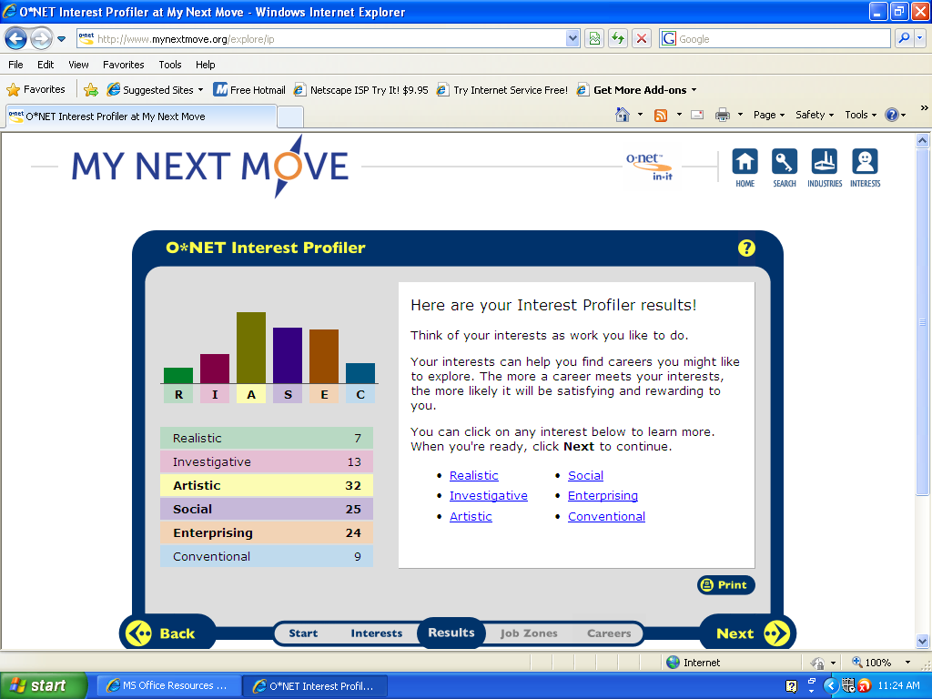

Artistic, social, and enterprising are the interests that the quiz said best represent me. I feel that this is a mostly accurate observation. I am artistic in the sense that I am very creative and open minded. Like the quizzes and articles said, I am unconventional and intuitive. My independent spirit and curious nature are the reasons I enjoy hands-on studio art and art studies, speaking foreign languages, learning about different cultures, and traveling. The courses I most enjoy in school are art courses, and I typically do well in them.
I do consider myself a social person. I am social in the sense that I am good at leading and communicating with others. I often mediate tough situations and succeed in planning details. I enjoy working in groups, joining clubs, being at parties or meetings, meeting new people, and training and assisting others. I like being able to see different perspectives and share and discuss ideas and beliefs with others.
However, I disagree with the idea that the category of enterprising suits me. People with an interest in enterprising like to talk about politics and often have an interest in the stock market and the progress of different businesses. Power, status, financial rewards, and opportunity for advancement or independence are all important to someone in enterprising. I do not feel this accurately describes me, because I do not see power, status, or financial reward as an important element in deciding my career. I am interested in current events and issues that are of the social nature and are personal, rather than political. I am often too focused on the creative area of something to pay attention to the business aspects of it, and business does not interest me.
Careers in the Social category that interest me:
Mental Health Counselor
Probation Officer
Massage Therapist
Child Care Worker
Librarian

Careers in the Artistic/ Creative category that interest me:
Writer
Makeup Artist
Talent Director
Interpreter

-Mental Health Counselor
HR1. Mental Health Counselors treat a variety of mental and emotional disorders and personal issues, such as depression, anxiety, low self-esteem, trauma, suicidal behavior, impulses, addiction, and grief, and work to help people understand and handle these disorders.
HR2. Mental health counselors work with doctors, nurses, school counselors, social workers and psychiatrists. Similar careers are vocational counselors, rehabilitation counselors, and marriage and family therapists.
HR3. A social personality is the best personality type for this field.
HR4. A master’s degree, a certification exam, and 2 years or 3,000 hours of clinical experience, are all typically required to be certified in any sort of counseling. Experience in teaching is required in some states.
HR5. People skills are more necessary in this field than technology skills. However, it is important that counselors be adept at email and other tech communications, as well as keeping and reading records.
RC1. The lowest 10% wage for a Mental Health counselor in 23008 was $29,360 and the highest 10% made $82,330.
RC2. The projected career growth in the field of Mental Health Counseling is 24%.
RC3. CounselingRI, Massachusetts Society for the Prevention of Cruelty to Children, and Y.O.U. Inc. are some local organizations that would hire mental health counselors.
ISC1. Mental health counselors can work in private offices, hospitals, and health centers. Some work a full day so they can always be on hand in hospitals. Others are paid for each appointment or meeting they have with a client and often have space between appointments.
ISC2. Counselors are part of collective bargaining units.
ISC3. Mental Health Counselors often start their career with an internship or training. They then move up to a part time counselor, and have the option to move up to full-time. There is also an opportunity to work as a private counselor or work for a State’s department of education. There are also several opportunities to move to different types of counseling in the mental health field, such as trauma, substance abuse, and prevention.

-Probation Officer
HR1. Probation officers counsel offenders and help them create plans for when they are no longer in jail or on parole.
HR2. Parole officers and pretrial service officers are similar to probation officers.
HR3. A social personality is the best personality type for this job.
HR4. A bachelor’s degree in a field related to psychology, social work, or criminal justice is required, though some require a master’s degree in one of these if you lack experience in a related position.
HR5. Technology skills such as internet communication, researching, and tracking are necessary for this job.
RC1. In the field of probation officers in 2008, the lowest 10 percent earned less than $29,490, and the highest 10 percent earned more than $78,210.
RC2. There is a projected growth of 19% over the next few years.
RC3. The Probation Office and MA parole board would hire someone in this career.
ISC1. Probation officers are employed by state governments, local governments, or both. They generally work 40 hours a week or more, but are on call 24/7.
ISC2. Probation officers are part of collective bargaining units.
ISC3. Advancement opportunities include getting a higher paying position through more experience, and possibly becoming a supervisor.

-Massage Therapist
HR1. Massage therapy promotes physical health, reduces stress, softens overworked muscles, and works to rehabilitate injuries.
HR2. A similar occupation is physical therapy.
HR3. A social personality is the best personality of type for this job.
HR4. A high school diploma, 500 hours of study, training programs, an examination, and periodic renewal of license are required to become (and remain) a massage therapist.
HR5. Technology skills such as using tools for advertising and online communication are helpful for this job.
RC1. In 2008, the lowest 10 percent of Massage Therapists earned less than $8.01 an hour, and the highest 10 percent earned more than $33.47 an hour.
RC2. A 19% growth in the massage therapy industry is projected in the next 8-10 years.
RC3. Elements Therapeutic Massage, Boston Bodyworker, and Namaste Massage are local and would all hire a massage therapist.
ISC1. Massage therapists can work in private and home offices, hospitals, nursing homes, and fitness and sports centers. They work between 15 and 40 hours a week, and typically work on an appointment-by-appointment basis, though some are on hand for walk-ins at more commercial places.
ISC2. Massage therapists are part of collective bargaining units.
ISC3. Advancement opportunities are limited. With experience, therapists can gain more clientele, can sometimes become managers of the officers they work in, or can become self-employed.

-Child Care Worker
HR1. Child care workers teach and supervise children who are not yet in school, and sometimes supervise before and after school programs.
HR2. Teaching and nursing are related fields of work.
HR3. A social personality type is best for this occupation.
HR4. State requirements for Child Care Workers vary. Some requite a Child Development Association or Child Care Professional credential, while others require less than a high school diploma.
HR5. Technology skills such as internet communication are helpful in this job.
RC1. The lowest 10 percent of Child Care Workers earned less than $7.04 an hour, and the highest 10 percent earned more than $13.98 and hour.
RC2. The projected growth of this career is about 11% over the next 8-10 years.
RC3. Local preschools such as the John Boyd Center and Happy Feet would hire a Child Care Worker.
ISC1. Child Care Workers typically work between 4 and 12 hours a day, for 9 or 10 months out of the year. Some work year round to care to the needs of children whose parents work year round.
ISC2. Similar to teachers, Child Care Workers are part of collective bargaining units.
ISC3. Child care workers can advance to different age groups or schools, or end up in higher positions in a single school, like principal, vice principal, or supervisor. There is also the option of running an in-home private child-care center, which could result in financial independence.

-Librarian
HR1. Librarians use a variety of sources to obtain information for personal and professional use. They catalogue, classify, provide, and acquire information.
HR2. A related occupation field is teaching.
HR3. A social personality type is best suited for this occupation.
HR4. Entry into a library science program or a degree from one of the 49 schools in the American Library Association is preferred. Certification requirements vary from state to state and specialized libraries such as law or science also require supplemental education in the specialized field.
HR5. Many, many technology skills are required to become a librarian. Internet communication skills, cataloguing, record keeping, searching, computer organization, web content managing, publishing, reference tool development, and accessing and utilizing databases are all vital skills in a modern library. Automated systems librarians need even more technology skills, as they design information storage and retrieval systems.
RC1. The lowest 10% of Librarians earned less than $33,190 annually, and the highest 10 percent earned more than $81,130.
RC2. The projected growth in the librarian career is 8% over the next 8-10 years.
RC3. Local libraries, such as the Somerset and Fall River public libraries, as well most local colleges, would hire librarians.
ISC1. Librarians typically work regular business hours, and 8 hour shifts. Some more advanced or fast-paced places require them to work more often. Most college librarians also work weekends and evenings, while elementary and middle school librarians typically work the same hours as the school’s teachers.
ISC2. About 30% of librarians are members of a union.
ISC3. Librarians are offered a few opportunities for advancement. With more experience, they can gain more hours and shifts. There is almost always the opportunity to work at a larger or busier library, and with specialization skills and experience, a specialized or business library.

-Writer
HR1. Writers create text to demonstrate the meaning of something, like an idea or story, or make a point. They can work for magazines, journals, newspapers, radio, television, and many other corporations and companies, or work freelance.
HR2. Related occupations include editor, publisher, and reporter.
HR3. A creative or artistic personality type is best for this career.
HR4. A professional writer or editor should have a college degree. Communications and English are the two most important types of courses to take in preparation. If a writer plans to write specifically about one thing, they should take courses about their specialization; such as science, history, or journalism.
HR5. Technology skills like word processing, publishing, and online communication are important for today’s writers.
RC1. The lowest 10 percent of authors and writers earned less than $28,020, and the highest 10 percent earned more than $106,630.
RC2. The projected growth over the next 10 years or so is about 7%, although jobs as a writer are very competitive.
RC3. Newspapers like the Spectator or Herald News would hire a writer.
ISC1. Writers’ salaries are based on a production schedule and whether or not they follow it, and are paid per assignment, working as many hours necessary to complete it. Writing consumes much of a writer’s time and they can work nearly anywhere and anytime.
ISC2. Writers are often members of unions. Unions range from National, which includes all types of writers, to specialized, like a Journalist Union.
ISC3. Writers do not have much room for advancement or promotion. Newspapers may promote writers to more important stories, and book editors may give them the go-ahead for a longer or more in-depth book. In general, bigger and better assignments may be given to them with time and experience, thus increasing pay, but there are not many “higher” positions a writer can go into.

-Theatrical and Performance Makeup Artist
HR1. Theatrical and Performance Makeup Artists use cosmetics to alter the visual appearance of a performer for television, theater, or movies.
HR2. Cosmetologists, hairdressers, and special effects creators have similar occupations to a makeup artist.
HR3. Both social and creative personality types are best for this profession.
HR4. Courses in art and design are preferred. Specialized training in cosmetology and a license are required in most states.
HR5. Online communications, organization, and advertising are important skills for makeup artists.
RC1. The lowest 10% of theatrical and performance makeup artists make $22,510 and the highest 10% make around $77,420.
RC2. A 17% growth rate is expected in the next 10 years.
RC3. Some theatres and local party and event companies, such as High Hat Productions, would hire someone in this position.
ISC1. Makeup artists work on an appointment/ assignment basis. They have a wide range of hours that vary per client.
ISC2. Makeup artists are typically not part of unions.
ISC3. Opportunities to advance include a change from local to national work and from smaller productions to larger ones.

-Art Director
HR1. Art directors develop design concepts and the direct the overall vision of a work.
HR2. Designers, graphic designers, and illustrators are all in a way similar to art directors.
HR3. A creative or artistic personality is best for this sort of job.
HR4. Art Directors are required to have a Bachelor’s degree and at least a year of work experience. A degree in management or fine arts is preferred. Demonstrating superior leadership and artistic abilities can take a designer or artist from their profession to being an Art Director.
HR5. Online communication is vital for this position. One must be able to communicate with all designers and artists on the job at all times to ensure that things run as planned. The ability to transfer art into a digital format through scanning and copying is also needed.
RC1. The lowest 10 percent of Art directors annually earned less than $40,730, and the highest 10 percent earned more than $154,840 in 2008.
RC2. The projected growth of this career is 12% over the next 10 years.
RC3. The Boston Museum of Fine Arts, the RISD museum, Complements Gallery, and as220 would all hire an art director.
ISC1. Art Directors generally work a standard workweek, unless an event calls for them to stay later.
ISC2. Art directors are sometimes parts of unions, such as the Art Directors Guild.
ISC3. Typically, after 5-10 years of experience larger museums take notice of good work and will hire. Art Directors in larger museums can get paid over $154,800 a year.

-Interpreter
HR1. And interpreter translates spoken words to relay concepts and ideas between languages.
HR2. Translating and teaching a foreign language are similar to being an interpreter.
HR3. Both a social and creative personality type is best suited for this job.
HR4. Knowing a minimum of two languages is required. A bachelor’s degree is often required for one of these jobs, though a major is any language is not required. For a specialized field such as engineering or finance, courses in the specialization are necessary to grasp every concept and term related to it. There is no universal certification for interpreters in general, though federal courts offer certification for a few different languages. The National Association of Judiciary Interpreters and Translators offers a certification as a court interpreter.
HR5. If working in translation as well as interpreting, a strong computer science background, knowledge of different types of software, and online communication are absolutely vital.
RC1. The lowest 10 percent of interpreters earned less than $22,170 in 2008, and the highest 10 percent earned more than $69,190.
RC2. The field of Interpreting and Translating is expected to grow 22% over the next 10 years or so.
RC3. Rhode Island Children’s Hospital, Hasbro hospital, and many other hospitals and clinics would hire an interpreter.
ISC1. Many interpreters are self-employed, and therefore work on a need-only basis. Others are employed in social services, hospitals, courts, educational institutions, telephones companies, and airlines. They typically work the hours of the business they are at, but on days off they are often on call in case they are needed. Guide and escort interpreters are hired to accompany an individual visiting the U.S. and travel often with clients.
ISC2. As of early 2011, most translators are now part of collective bargaining units.
ISC3. With increased experience comes more complex and prestigious translating assignments. Interpreters can advance to having training and editorial responsibilities, manage or assist in managing an agency, or start a translation agency of their own.

My top two career choices are Interpreter and Theatrical and Performance Makeup Artist. Although being a librarian is an interesting and surely fulfilling career, I am not sure it could become a passion of mine. Eight years of schooling are required to become a librarian, and in such a rough economy I think it would be impractical to imagine that I could afford eight years of schooling. The physical demand of going to school full time and working could be very overwhelming after eight years. Although a librarian makes more than the other two careers, the money difference is not enough to sway me in the direction of a career that requires such rigorous schooling to prepare me for a very limited job market. The projected growth of the field is only 8% over the next ten years. As an Interpreter I would be much more in demand, with the rate of growth being at 22%. Being an interpreter is a practical choice because it would allow me to help people all around the world, make a good amount of money, and only requires moderate schooling. Being a Theatrical Performance Makeup Artist is also a practical choice, because it requires the least amount of schooling of my three choices, saving me money and allowing me to get an early start on my career. Cosmetology is already a natural talent of mine, and being able to do work that interests me will make me happy. Both are more sensible choices than a librarian to me because they would allow me to book my own schedule, allowing time for family. It is easier to manage stress and work around any issues that may arise when one is working on an appointment basis. They also both have the option of travel, which would allow me to meet a huge range of people, see new places, and experience different cultures. Being an interpreter would even allow me to travel worldwide.

Colleges/ Training for Interpreting:
-Bethesda University of California
-Salem State University
-Bard College

Colleges/ Training for Theatrical Makeup:
-Montclair State University
-West Tennessee Business College

